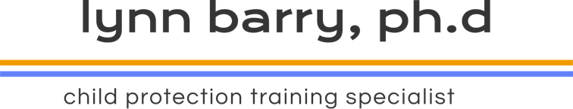

**ABOUT THE PROGRAM**

**How you register**

**What you need to register**

Computer with internet

An email address

Ability to download ZOOM Link

**Cost for the series**

$595.00

**Contact Information**

Lynn Barry

Website: lynnbarry.org

[Lynnbarry287@gmail.com](mailto:Lynnbarry287@gmail.com)

Text: (403) 875-6606

Lynn Barry is committed to providing child protection workers and police officers with quality and current evidence-based training on child interviewing, regardless of their proximity to an urban training centre.

This *online* cost-effective 14-hour course is designed for the busy professional to complete in 6 two-hour sessions, with an additional two hours of expected practice. Participants will be given feedback on submitted practice recordings.

Session 1: Accountability and skill building

Session 2: Child development, language, suggestibility

Session 3: Free narratives and question formation

Session 4: Identifying and coding question types

Session 5: The structure of the child interview

Session 6: Putting it all together

January 10, 17, 24, 31; February 7,15, 2024 5-7 PM MST

April 17, 24; May 1, 8, 15, 22, 2024 5-7 PM MST

September 11,18, 25, October 2, 9, 16, 2024 5-7 PM MST

**SESSION DATES AND TIME**



ONLINE

**Child investigative interviewing training**

For child protection workers and police officers

**2024**