

**ABOUT THE PROGRAM**



ONLINE

**Child investigative interviewing training**

Reclaiming the investigative interview in child protection

**2024**

**How you register**

<https://www.lynnbarry.org/event-details/child-investigative-interviewing-training-courses-2024-01-10-17-00>

**What you need to register**

Computer with internet

An email address

Ability to download ZOOM Link

**Cost for the series**

$595.00

**Contact Information**

Lynn Barry

Website: lynnbarry.org

[Lynnbarry287@gmail.com](mailto:Lynnbarry287@gmail.com)

Text: (403) 875-6606

Lynn Barry is committed to providing child protection workers with quality and current evidence-based training on child investigative interviewing, regardless of proximity to an urban training centre.

Child protection workers have unique mandates, obligations, required interview processes, and safety assessments that are not addressed in forensic interviewing protocols or training. The potentially intrusive outcomes of investigative interviews for children and families should necessitate the same high quality of interviewing competencies and transparency as forensic interviewing.

This *online* cost-effective 14-hour course is designed for the busy professional to complete in 6 two-hour sessions, with an additional two hours of expected practice. Participants will be given feedback on submitted practice recordings.

Session 1: Accountability and skill building

Session 2: Child development, language, suggestibility

Session 3: Free narratives and question formation

Session 4: Identifying and coding question types

Session 5: The structure of the child interview

Session 6: Putting it all together

**January 10, 17, 24, 31; February 7,15, 2024 5-7 PM MST

**April 17, 24; May 1, 8, 15, 22, 2024 5-7 PM MST

**September 11,18, 25, October 2, 9, 16, 2024 5-7 PM MST

**SESSION DATES AND TIME**

**ABOUT LYNN BARRY**

Lynn Barry, Ph.D. worked as a front-line child protection worker conducting forensic interviews for many decades, while also teaching child forensic and investigative interviewing to child protection workers, police officers, and Crown prosecutors and is well-versed on the latest research.

Lynn was the founder and director of the Canadian Society for the Investigation of Child Abuse from 1985-2015 and coordinated and produced “For the Kids”: A Sexual Abuse Training Program for Police and Social Workers (1985); and “You’re Not Alone”: A Child Witness Court Preparation Training Program (1992).

Lynn was awarded a 2005 Centennial Medal by the Alberta Government for her contributions to the field of social services. She is recognized in the courts as an expert witness in child abuse interviewing and child development.

**TESTIMONIALS**

Over the years, Lynn's teachings, encouragement and modelling of child investigative interviewing endures! I would say the person I learned the most from and aspire to be like in my practice is Lynn Barry (Carol Overdevest, retired child protection worker, Calgary).

I know from my years working with Dr. Lynn Barry, there is no one more competent to provide child investigative training. Lynn has made it her life work to ensure children are respected throughout their ordeal; through the initial investigation to any court processes, and hopeful recovery and follow up. Lynn has worked hard to provide training for initial investigators in this field of forensics (Det. Peter. Johnston, Retired Calgary Police Service).

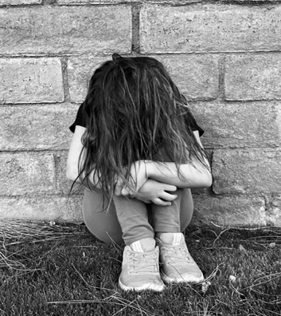

Throughout the three decades that Lynn Barry and I have

collaborated, I have been impressed by her wisdom and her

passion for important but oft-neglected issues such as child abuse

investigation and Premenstrual Syndrome. We are currently

submitting our research to peer refereed journals. A role model for

social work practitioners! (Dr. Leslie Tutty, Professor Emeritus,

University of Calgary).

**the C**